Discussion:

This was a really great topic! I actually did a presentation at work towards the end of last year that talked about correlation vs. causation and how to differentiate the two. I found some hilarious examples that I can share here as well.

To me, correlation is not causation means that just because you can identify a relation between two instances, does not mean that one causes the other to occur. The example provided in the article “Does This Ad Make Me Fat” proves that just because there is a large number of food ads, and that there are a large number of obese people in that area does not mean that one causes the other. Just from a realistic standpoint, there are several factors that can come into play when looking at that research. First, they conducted the study in an urban area, where there are a lot more ads for food than there would be in a rural area. Also, other socio-economic factors may come into play as well. People living in the city may be in a rush and would rather stop at a McDonalds than make a home cooked meal. Or for some, that are less fortunate, they may find that eating junk food is cheaper than buying organic foods. Which then increases the obesity rate for that urban area.

Some other great instances that I’ve found when it comes to correlation vs. causation are the following:

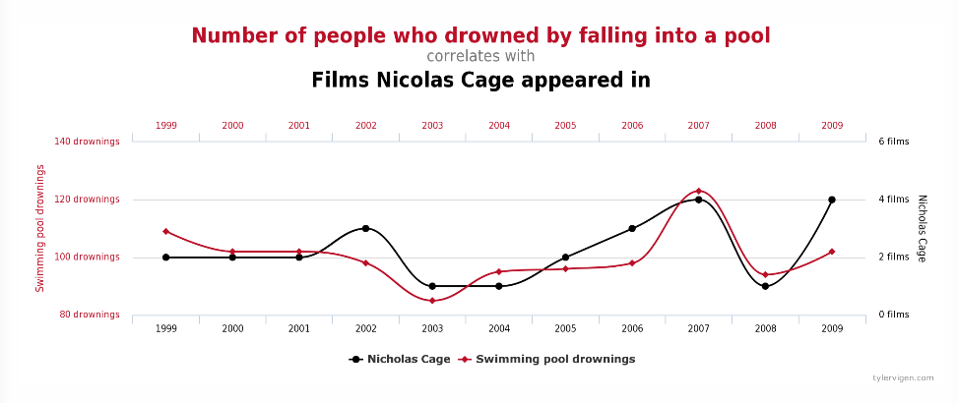

This outlines the correlation that the number of people who drowned by falling into a pool is similar to the appearances of Nicholas Cage’s movies. Any reasonable person knows that these do not have a causation, but for comedic purposes one could infer that after watching a Nicholas Cage movie, one may want to commit suicide.

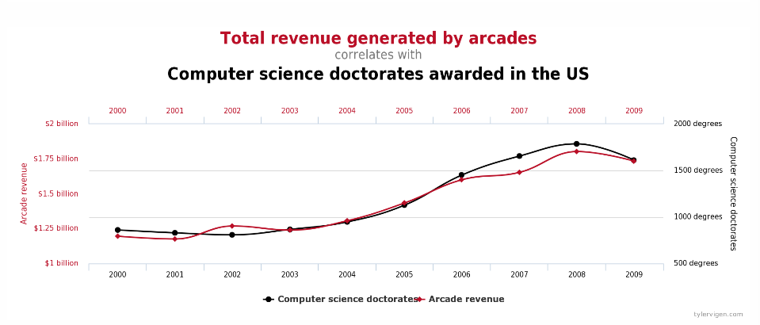

Another correlation that is found is that the total revenue by arcades matches with the amount of computer science doctorates awarded. Obviously, there is no causation here, but you could say that after getting a computer science degree, most computer science doctorates wanted to go celebrate at an arcade.

Vigen, T. (n.d.). 15 Insane Things That Correlate With Each Other. Retrieved April 20, 2017, from <http://www.tylervigen.com/spurious-correlations>